**IFT 166 Introduction to Internet Networking**

**Lab 22  
Troubleshooting Utilities**

**After you complete each step, put a ‘√’ or ‘x’ in the completed box**

* We need to test the network for connectivity i.e. connectivity to the servers, gateway/router etc.
* Use ip config, ping, tracert, nslookup, netstat

1. Open the command prompt and type in **ipconfig**

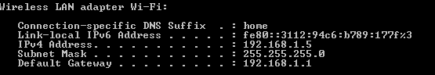

1. This command shows the IP address, Subnet Mask and default gateway. It is useful if you set the client up to DHCP as you cannot see this information by going to the NIC and right clicking and looking at properties (you cannot see what IP address you received). However, we do not see our DNS servers for examples



1. Now type **ipconfig /all** (allows us to see more stuff e.g. more servers, IPv6 information)

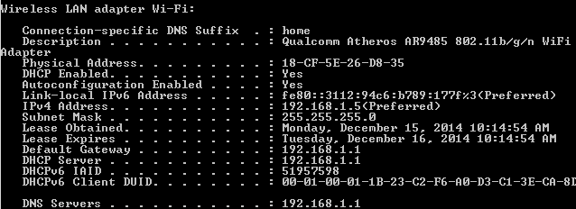



1. **Ping:** allows you to see if we are connected in the network e.g. if you can get a response from your routers. Allows you ping other computers on the network and see if they are reachable,
2. Ping the default gateway (based on the address your got from running the ipconfig /all command)

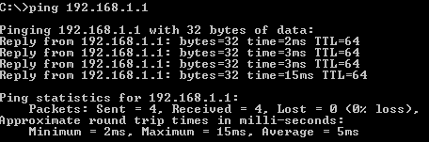



1. You can even ping domain names (ping yahoo.com)

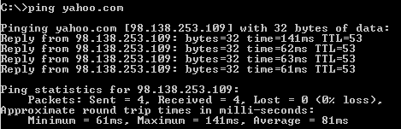



1. **Tracert:** almost like ping but much more detailed. As the request for replies travel across the Internet, each router along the way will send a return message back (tracert yahoo.com)

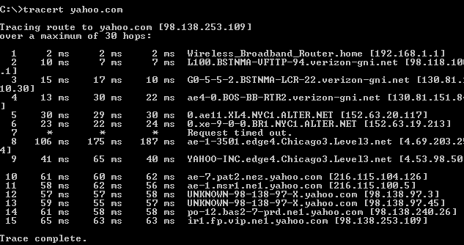



1. **Nslookup** (Name Server lookup): resolves a name to an IP address. When we pinged yahoo.com, we got messages back but behind the scenes, DNS was resolving these names to IP addresses. Nslookup allows us to find those IP addresses straight away.

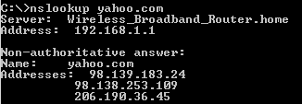



1. **Netstat:** useful for seeing whether we have listening TCP ports or network connections on our system.



